哈尔滨工业大学计算学部
实验报告

课程名称：数据结构与算法
课程类型：专业基础（必修）
实验项目：图形结构及其应用
实验题目：最短路径算法
实验日期：2021/11/6

设计成绩 | 报告成绩 | 指导老师
 |  | 张岩

一、实验目的
最短路径问题研究的主要有：单源最短路径问题和所有顶点对之间的最短路 径问题。在计算机领域和实际工程中具有广泛的应用，如集成电路设计、GPS/游戏地图导航、智能交通、路由选择、铺设管线等。理解、实现并运用两种最短路径算法：Dijkstra算法和Floyd-Warshall算法，求解图的最短路径。
二、实验要求及实验环境
实验要求：
1、实现单源最短路径的Dijkstra算法，输出源点及其到其他顶点的最短路径长度和最短路径。
2、实现全局最短路径的Floyd-Warshall算法。计算任意两个顶点间的最短距离 矩阵和最短路径矩阵，并输出任意两个顶点间的最短路径长度和最短路径；
3、利用Dijkstra或Floyd-Warshall算法解决单目标最短路径问题：找出图中每 个顶点v到某个指定顶点c最短路径；
4、利用Dijkstra或Floyd-Warshall算法解决单顶点对间最短路径问题：对于某 对顶点u和v，找出u到v和v到u的一条最短路径；
5、以文件形式输入图的顶点和边，并显示相应的结果。要求顶点不少于10个， 边不少于13个；
6、（选做）利用Floyd-Warshall算法，计算有向图的可达矩阵，理解可达矩阵的含义；
7、利用堆结构（实现的优先级队列），改进和优化Dijkstra算法的实现。

实验环境：
Sublime Text3编辑，gcc编译

三、设计思想（本程序中的用到的所有数据类型的定义，主程序的流程图及各程序模块之间的调用关系、核心算法的主要步骤）
1．逻辑设计
- 利用邻接矩阵存储有向图
- 利用堆结构优化Dijkstra算法
- 堆节点设计：
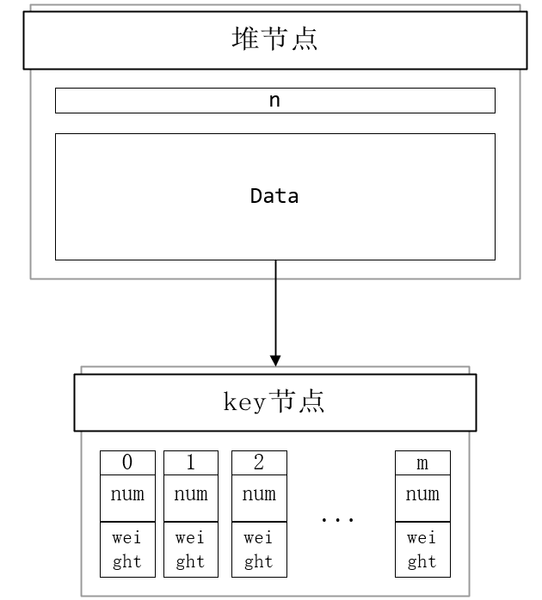

2．物理设计
程序流程图如下：
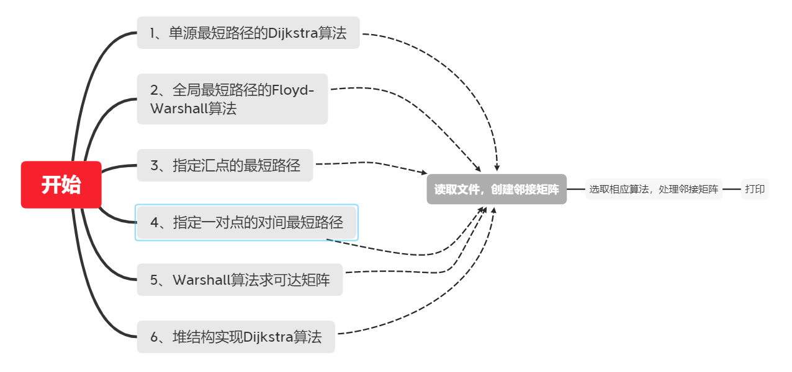
函数调用如下：
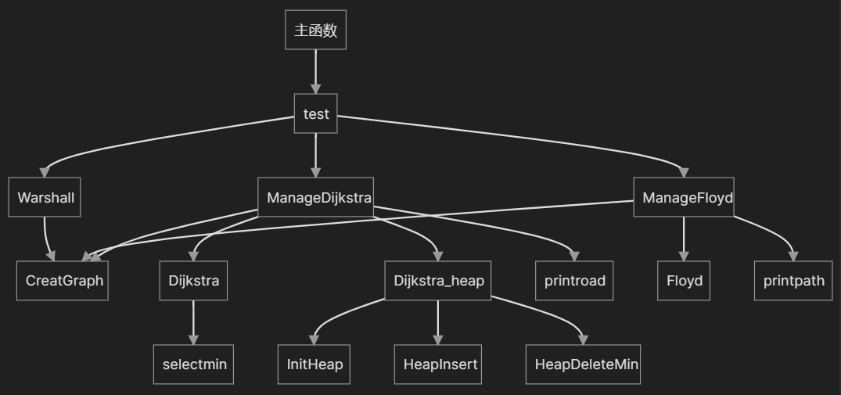
四、测试结果
测试数据如下：
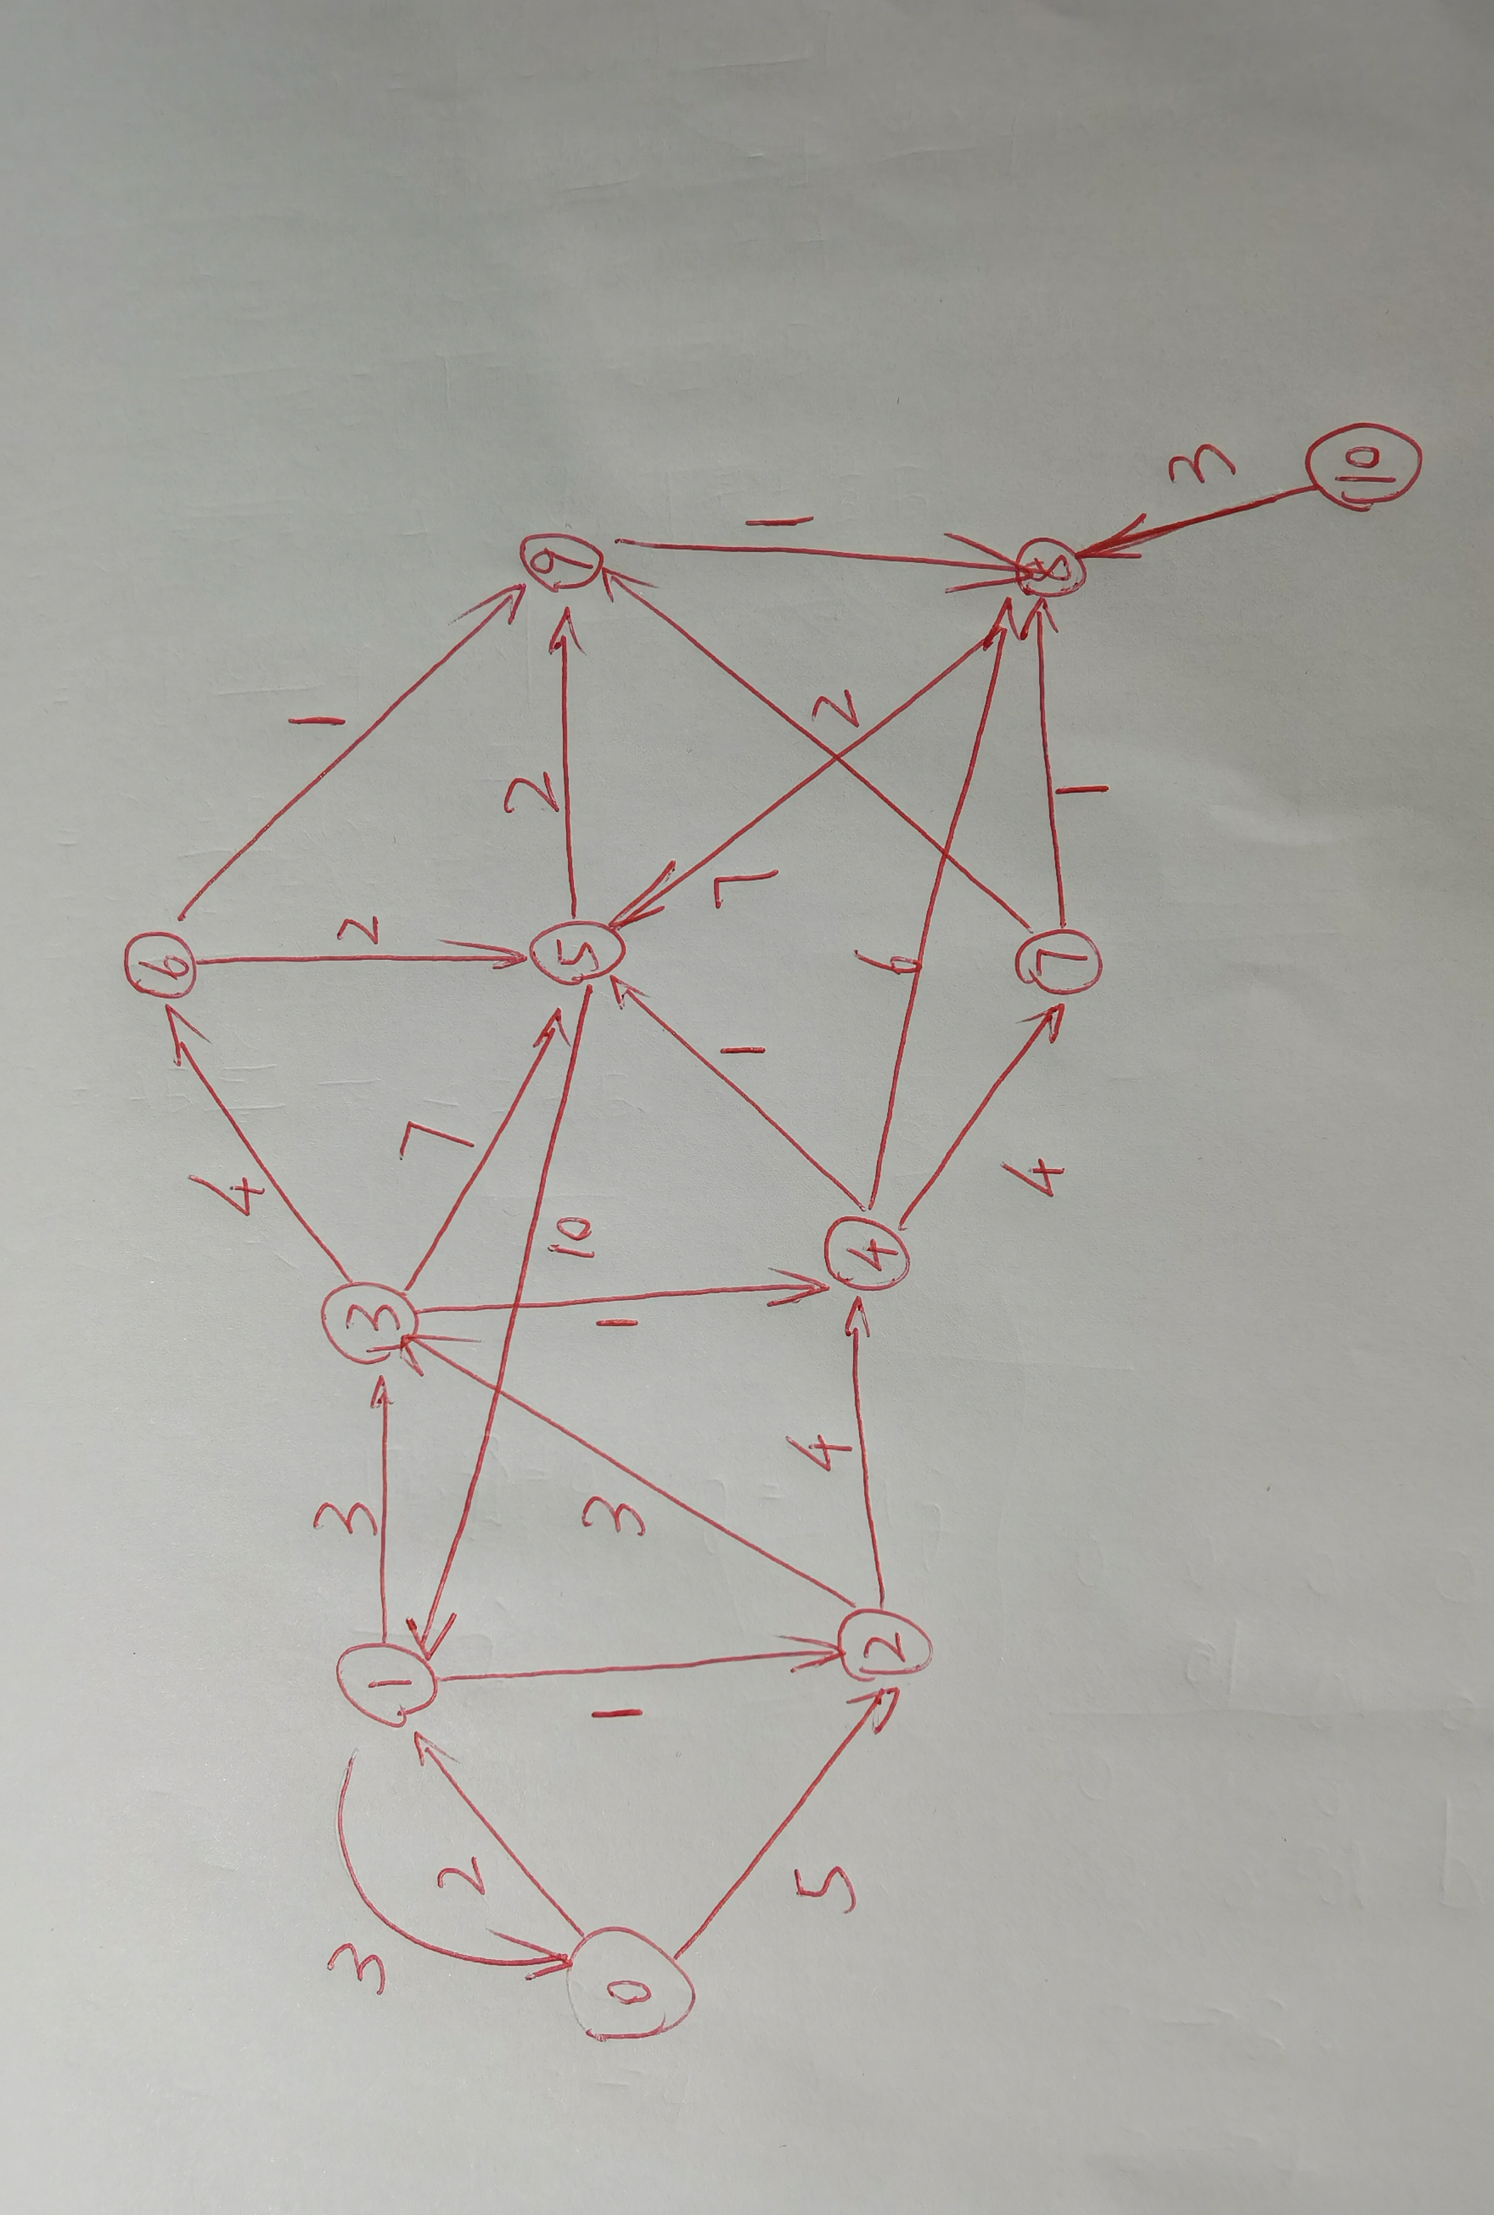
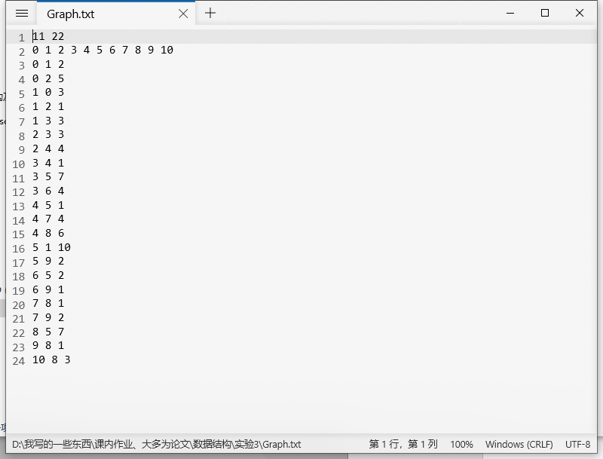
- 单源最短路径的Dijkstra算法：
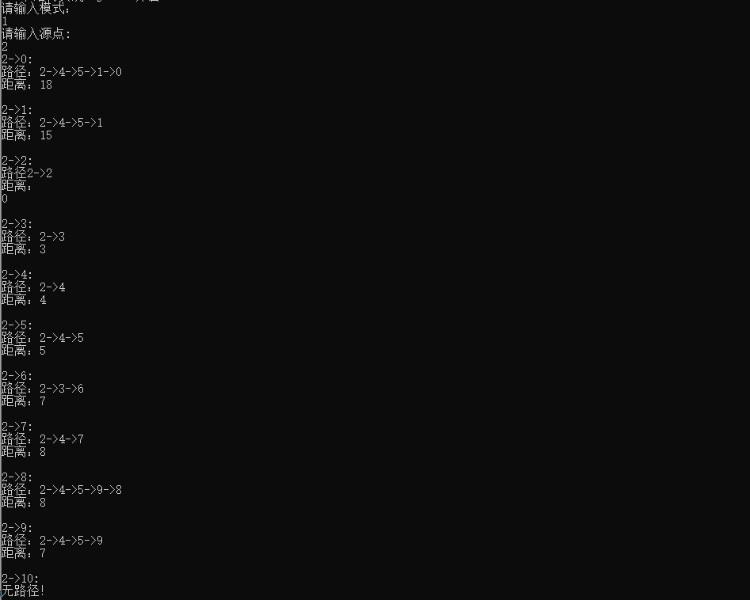
- 全局最短路径的Floyd-Warshall算法
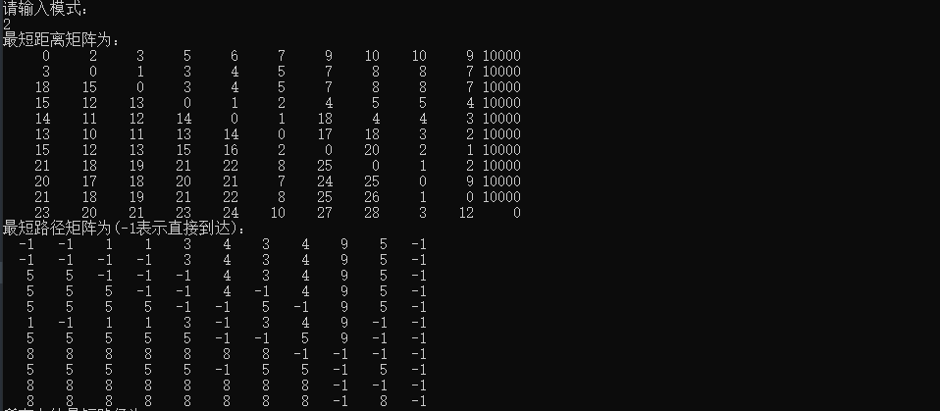
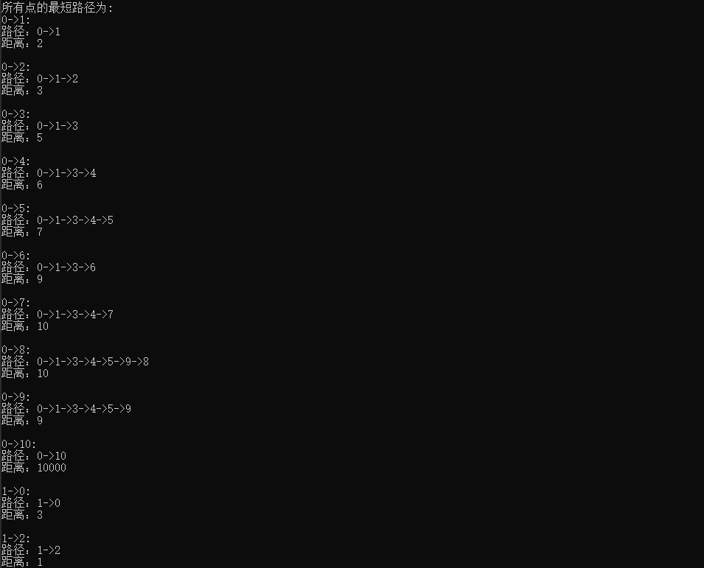
中间部分省略
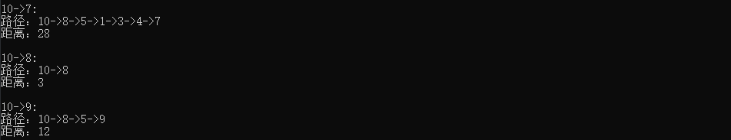
- 指定汇点的最短路径
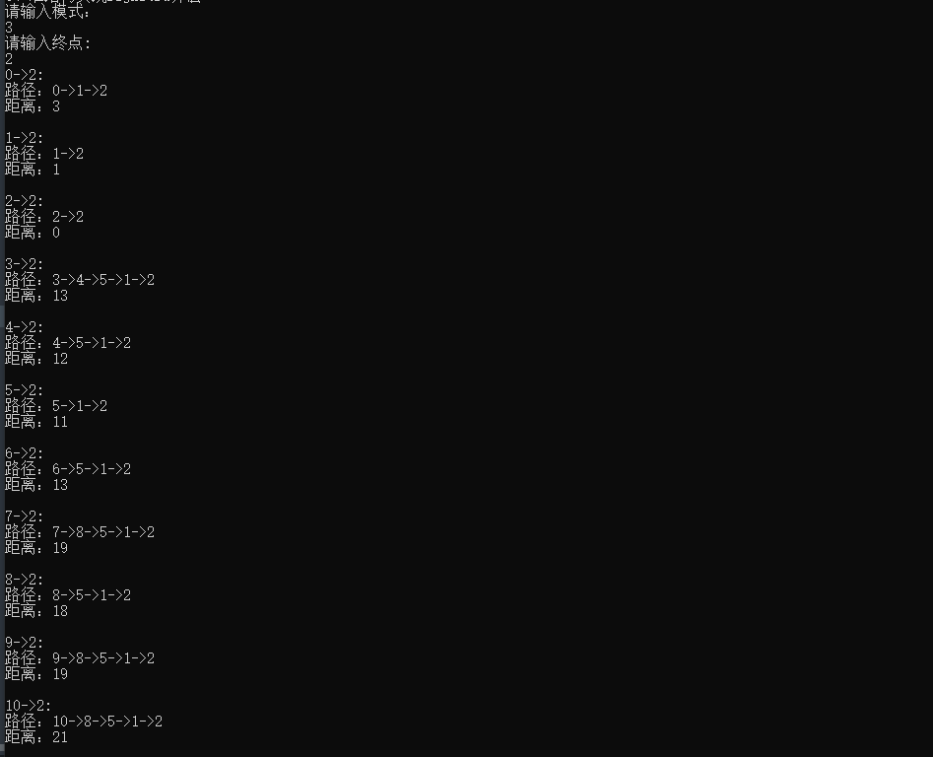
- 指定一对点的对间最短路径
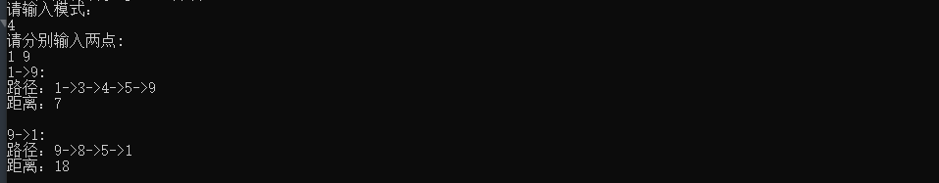
- Warshall算法求可达矩阵
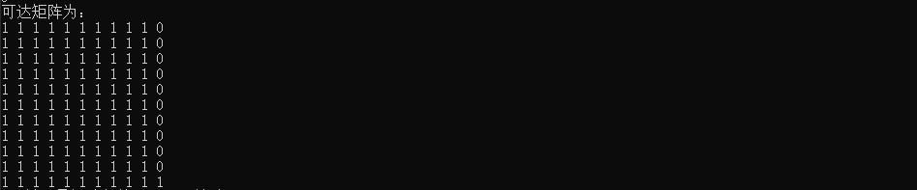
- 堆结构实现Dijkstra算法
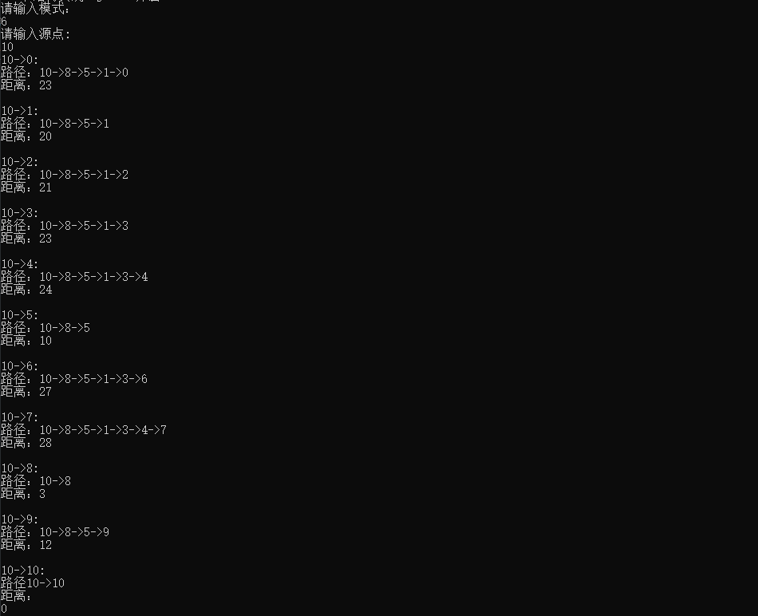
- 实验比较原始Dijkstra算法与堆结构实现Dijkstra算法
堆优化的时间复杂度为mlog(n)，原始的为n^2由于我这里的图顶点只有十几个，所以n和log(n)差别不大，而m>n，所以就会导致堆优化的运行时间反而更长。在大数据的情况下， 我相信堆优化的运行时间会更短。
五、经验体会与不足
经验：
- 熟练掌握了求最短路径的这两大算法
- 用堆优化了Dijkstra算法
不足：
部分函数架构没有设计好，导致整个程序代码冗长，重复地方多。
六、附录：源代码（带注释）

- #include<iostream>
- #include<iomanip>
- #include<fstream>
- using namespace std;

- #define inf 10000//定义无穷大
- //邻接矩阵表示有向图
- #define VertexData int
- #define EdgeData int
- #define Numvertices 20

- typedef struct {
- VertexData vertex[Numvertices];
- EdgeData edge[Numvertices][Numvertices];
- int n;
- int e;
- } Graph;
- //堆结构
- //最小堆
- typedef struct {
- int num;
- int weight;
- } ElemType;
- typedef struct {
- ElemType data[Numvertices];
- int n;
- } heap;
- //堆功能
- void InitHeap(heap& heap);//初始化
- bool isHeapEmpty(heap heap);//判空
- bool HeapFull(heap heap);//判满
- void HeapInsert(heap& heap, ElemType m);//插入
- ElemType HeapDeleteMin(heap& heap);//删除最小

- void InitHeap(heap& heap) {
- heap.n = 0;
- }
- bool isHeapEmpty(heap heap) {
- return (!heap.n);
- }
- bool HeapFull(heap heap) {
- return (heap.n == Numvertices - 1);
- }

- void HeapInsert(heap& heap, ElemType m) {
- int i;
- if (!HeapFull(heap))
- {
- i = ++heap.n;
- while ((i != 1) && (m.weight < heap.data[i / 2].weight))
- {
- heap.data[i] = heap.data[i / 2];
- i /= 2;
- }
- }
- heap.data[i].num = m.num;
- heap.data[i].weight = m.weight;
- }
- ElemType HeapDeleteMin(heap& heap) {
- int parent = 1, child = 2;
- ElemType tmp, elem;
- if (!isHeapEmpty(heap))
- {
- elem = heap.data[1];
- tmp = heap.data[heap.n--];
- while (child <= heap.n)
- {
- if ((child < heap.n) && (heap.data[child].weight > heap.data[child + 1].weight))
- ++child;
- if (tmp.weight <= heap.data[child].weight)
- break;
- heap.data[parent] = heap.data[child];
- parent = child;
- child *= 2;
- }
- }
- heap.data[parent] = tmp;
- return elem;
- }
- /*--------------------------------------------------------------*/
- void CreatGraph(Graph *G) {
- ifstream file("Graph.txt");
- file >> G->n;
- file >> G->e;
- for (int i = 0; i < G->n; ++i) { //初始化
- for (int j = 0; j < G->n; ++j) {
- G->edge[i][j] = inf;
- }
- }
- for (int i = 0; i < G->n; ++i) { //对角线置1
- G->edge[i][i] = 0;
- }
- for (int i = 0; i < G->n; ++i) {
- file >> G->vertex[i];
- }
- for (int i = 0; i < G->e; i++) {
- int a, b, weight;
- file >> a >> b >> weight;
- G->edge[a][b] = weight;
- }
- }
- int selectmin(Graph* G, int d[], bool s[]) { //V-s中找到w使d[w]最小
- int temp = inf;
- int w = 0;
- for (int i = 0; i < G->n; i++) {
- if (!s[i] && d[i] < temp) {
- temp = d[i];
- w = i;
- }
- }
- return w;
- }
- //Dijkstra算法
- void Dijkstra(Graph *G, int start, int d[], int p[], bool s[]) {
- for (int i = 0; i < G->n; ++i) {
- d[i] = G->edge[start][i]; //初始化d
- s[i] = false;
- p[i] = start;
- }
- s[start] = true;
- for (int i = 0; i < G->n - 1; ++i) {
- int w = selectmin(G, d, s);
- s[w] = true;
- for (int v = 0; v < G->n; ++v) {
- if (!s[v]) {
- int sum = d[w] + G->edge[w][v];
- if (sum < d[v]) {
- d[v] = sum;
- p[v] = w;
- }
- }
- }
- }
- }
- //Dijkstra算法堆优化
- void Dijkstra_heap(Graph *G, int start, int d[], int p[], bool s[]) {
- heap heap;
- InitHeap(heap);
- for (int i = 0; i < G->n; ++i) {
- d[i] = inf;
- s[i] = false;
- p[i] = start;
- }
- d[start] = 0;
- ElemType temp;
- temp.num = start;
- temp.weight = d[start];
- HeapInsert(heap, temp);
- while (!isHeapEmpty(heap)) {
- temp = HeapDeleteMin(heap);
- int v = temp.num;//当前点
- if (s[v]) continue;
- s[v] = true;
- for (int i = 0; i < G->n; ++i) {
- if (d[i] > d[v] + G->edge[v][i]) {
- d[i] = d[v] + G->edge[v][i];
- temp.num = i;
- temp.weight = d[i];
- p[i] = v;
- HeapInsert(heap, temp);
- }
- }
- }
- }
- //Floyd算法
- void Floyd(int d[][Numvertices], Graph* G, int p[][Numvertices]) {
- for (int i = 0; i < G->n; ++i) {
- for (int j = 0; j < G->n; ++j) {
- d[i][j] = G->edge[i][j];
- p[i][j] = -1;//p记录中间节点
- }
- }
- for (int k = 0; k < G->n; k++) {
- for (int i = 0; i < G->n; ++i) {
- for (int j = 0; j < G->n; j++) {
- if (d[i][k] + d[k][j] < d[i][j]) {
- d[i][j] = d[i][k] + d[k][j];
- p[i][j] = k;
- }
- }
- }
- }
- }
- //打印路径算法
- void printroad(Graph* G, int start, int d[], int p[]) {
- for (int i = 0; i < G->n; ++i) {
- cout << start << "->" << i << ":" << endl;
- int temp = i;//记录路径节点
- int r[Numvertices];//保存路径节点
- int j = 0;
- if (d[i] == inf) {
- cout << "无路径！" << endl;
- cout << endl;
- }
- else if (i == start) {
- cout << "路径";
- cout << start << "->" << start << endl;
- cout << "距离：" << endl;
- cout << 0 << endl;
- cout << endl;
- }
- else {
- while (temp != start) {
- r[j++] = temp;
- temp = p[temp];
- }
- r[j++] = start;
- cout << "路径：";
- while (j--) {
- cout << r[j];
- if (j != 0)
- cout << "->";
- }
- cout << endl;
- cout << "距离：" << d[i] << endl;
- cout << endl;
- }
- }
- }
- //Dijkstra算法相关操作
- void ManageDijkstra(int mode) {
- Graph *G = new Graph;
- CreatGraph(G);
- int d[Numvertices];//源点0到顶点i的当前最短路径长度
- int p[Numvertices];//最短路径最后经过的点
- bool s[Numvertices];
- int start;
- cout << "请输入源点:" << endl;
- cin >> start;
- if(mode==1)
- Dijkstra(G, start, d, p, s);
- else
- Dijkstra_heap(G, start, d, p, s);
- printroad(G, start, d, p);

- }
- //最短路径矩阵得到任意两点路径(递归)
- void printpath(int p[][Numvertices], int i , int j) {
- int k = p[i][j];
- if (k != -1) {
- printpath(p, i, k);
- cout << k << "->";
- printpath(p, k, j);
- }
- }
- //输出问题2的Floyd算法,输出所有
- void PrintAns2Floyd(Graph* G, int d[][Numvertices], int p[][Numvertices]) {
- cout << "最短距离矩阵为：" << endl;
- for (int i = 0; i < G->n; i++) {
- for (int j = 0; j < G->n; j++) {
- cout << setw(6) << d[i][j];
- }
- cout << endl;
- }
- cout << "最短路径矩阵为(-1表示直接到达)：" << endl;
- for (int i = 0; i < G->n; i++) {
- for (int j = 0; j < G->n; j++) {
- cout << setw(4) << p[i][j] << " ";
- }
- cout << endl;
- }
- cout << "所有点的最短路径为:" << endl;
- for (int i = 0; i < G->n; ++i) {
- for (int j = 0; j < G->n; ++j) {
- if (i != j) {
- cout << i << "->" << j << ":" << endl;
- cout << "路径：";
- cout << i << "->";
- printpath(p, i, j);
- cout << j;
- cout << endl;
- cout << "距离：" << d[i][j] << endl;
- cout << endl;
- }
- }
- }
- }
- //输出问题3的Floyd算法,指定终点
- void PrintAns3Floyd(Graph *G, int d[][Numvertices], int p[][Numvertices]) {
- cout << "请输入终点:" << endl;
- int c;
- cin >> c;
- for (int i = 0; i < G->n; ++i) {
- while (d[i][c] == inf) {
- cout << i << "->" << c << ":" << endl;
- cout << "无路径！" << endl;
- cout << endl;
- i++;
- }
- cout << i << "->" << c << ":" << endl;
- cout << "路径：";
- cout << i << "->";
- printpath(p, i, c);
- cout << c;
- cout << endl;
- cout << "距离：" << d[i][c] << endl;
- cout << endl;
- }
- }
- //输出问题4的Floyd算法,指定起点和终点
- void PrintAns4Floyd(Graph *G, int d[][Numvertices], int p[][Numvertices]) {
- cout << "请分别输入两点:" << endl;
- int u, v;
- cin >> u >> v;
- if (d[u][v] == inf) {
- cout << u << "->" << v << ":" << endl;
- cout << "无路径！" << endl;
- }
- else {
- cout << u << "->" << v << ":" << endl;
- cout << "路径：";
- cout << u << "->";
- printpath(p, u, v);
- cout << v;
- cout << endl;
- cout << "距离：" << d[u][v] << endl;
- cout << endl;
- }
- if (d[v][u] == inf) {
- cout << v << "->" << u << ":" << endl;
- cout << "无路径！" << endl;
- return;
- }
- else {
- cout << v << "->" << u << ":" << endl;
- cout << "路径：";
- cout << v << "->";
- printpath(p, v, u);
- cout << u;
- cout << endl;
- cout << "距离：" << d[v][u] << endl;
- cout << endl;
- }
- }
- //Floyd算法相关操作
- void ManageFloyd(int mode) {
- Graph *G = new Graph;
- CreatGraph(G);
- int d[Numvertices][Numvertices];//最短距离矩阵
- int p[Numvertices][Numvertices];//最短路径矩阵
- Floyd(d, G, p);
- if(mode==2)
- PrintAns2Floyd(G, d, p);
- else if(mode==3)
- PrintAns3Floyd(G, d, p);
- else
- PrintAns4Floyd(G, d, p);
- }
- //Warshall算法
- void Warshall() {
- Graph *G = new Graph;
- CreatGraph(G);
- int nn[Numvertices][Numvertices];
- //邻接矩阵初始处理
- for (int i = 0; i < G->n; ++i) {
- for (int j = 0; j < G->n; j++) {
- if (G->edge[i][j] == inf)
- nn[i][j] = 0;
- else
- nn[i][j] = 1;
- }
- }
- for (int k = 0; k < G->n; k++) {
- for (int i = 0; i < G->n; ++i) {
- for (int j = 0; j < G->n; j++) {
- if (nn[i][k] && nn[k][j]) {
- nn[i][j] = 1;
- }
- }
- }
- }
- cout << "可达矩阵为：" << endl;
- for (int i = 0; i < G->n; ++i) {
- for (int j = 0; j < G->n; ++j) {
- cout << nn[i][j] << " ";
- }
- cout << endl;
- }
- }
- void test() {
- while(1){
- cout<<"1、单源最短路径的Dijkstra算法"<<endl;
- cout<<"2、全局最短路径的Floyd-Warshall算法"<<endl;
- cout<<"3、指定汇点的最短路径"<<endl;
- cout<<"4、指定一对点的对间最短路径"<<endl;
- cout<<"5、Warshall算法求可达矩阵"<<endl;
- cout<<"6、堆结构实现Dijkstra算法"<<endl;
- int mode;
- cout<<"请输入模式："<<endl;
- cin>>mode;
- switch(mode)
- {
- case 1:
- ManageDijkstra(1);
- break;
- case 2:
- ManageFloyd(2);
- break;
- case 3:
- ManageFloyd(3);
- break;
- case 4:
- ManageFloyd(4);
- break;
- case 5:
- Warshall();
- break;
- case 6:
- ManageDijkstra(2);
- }

- }
- }
- int main(void) {
- test();
- return 0;
- }

